**EXPERIMENT 7**

**Aim:** To configure IP address in following topology:

* Mesh Topology
* Star Topology
* Ring Topology
* Bus Topology

**Procedure: Mesh Topology:**

1. Pick Generic PC-PT and drag on the workspace. An icon with PC0 tag will appear.
2. Pick Generic PC-PT and drag on the workspace. An icon with PC1 tag will appear.
3. Pick Generic PC-PT and drag on the workspace. An icon with PC2 tag will appear.
4. Pick Generic PC-PT and drag on the workspace. An icon with PC3 tag will appear.
5. Pick Generic Switch-PT and drag on the workspace. An icon with Switch0 tag will appear.
6. Pick Generic Switch-PT and drag on the workspace. An icon with Switch1 tag will appear.
7. Pick Generic Switch-PT and drag on the workspace. An icon with Switch2 tag will appear.
8. Pick Generic Switch-PT and drag on the workspace. An icon with Switch3 tag will appear.

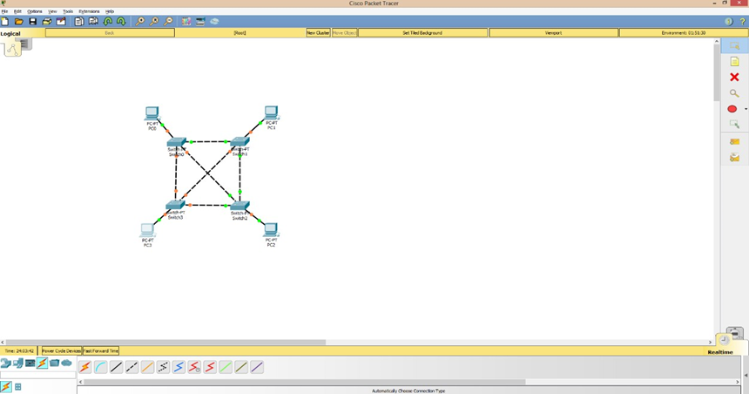

1. Use Copper Cross-Wire Cabling to connect all the Switches together with fast Ethernet 0/1, 0/2, 0/3 and 0/4 respectively.
2. Use Copper Straight-Through Wire Cabling to connect all the Switches with the PCs with fast Ethernet 0 to Switch0, Ethernet 1 to Switch1, Ethernet 2 to Switch2 and Ethernet 3 to Switch3 respectively
3. Double click PC0 and click on desktop configuration. Choose IP configuration and change IP to 172.16.1.1 and subnet mask to 255.255.0.0.



1. Double click PC1 and click on desktop configuration. Choose IP configuration and change IP to 172.16.1.2 and subnet mask to 255.255.0.0.
2. Add simple PDU (Protocol Data Unit), i.e., Packet and dropt it at PC0 and PC1.

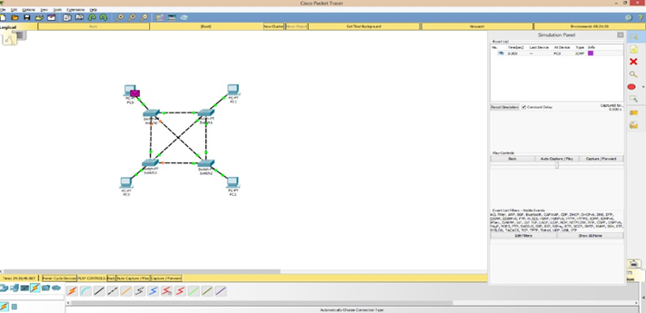

1. Click on Simulation button in right toolbar and click on Auto Capture / Play button.

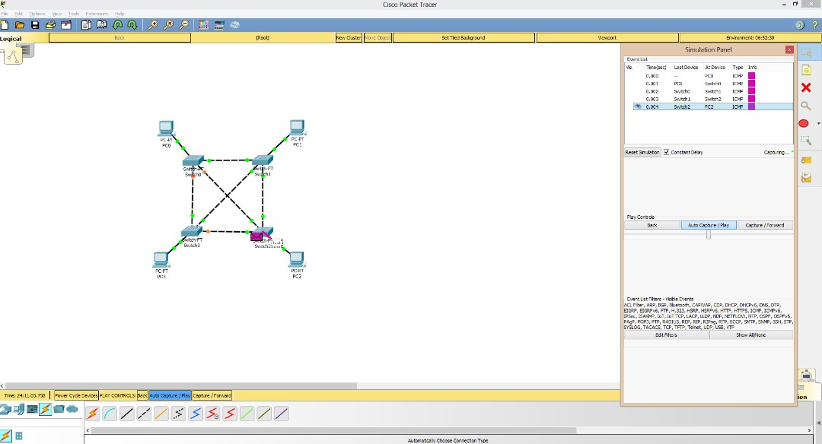

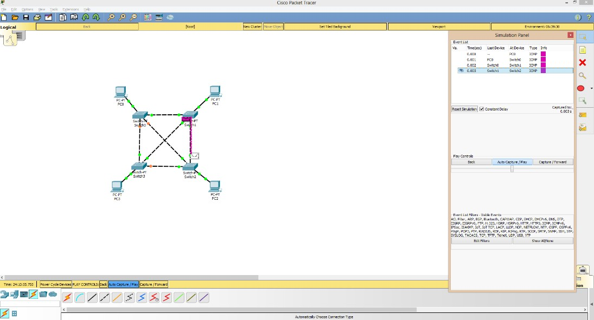

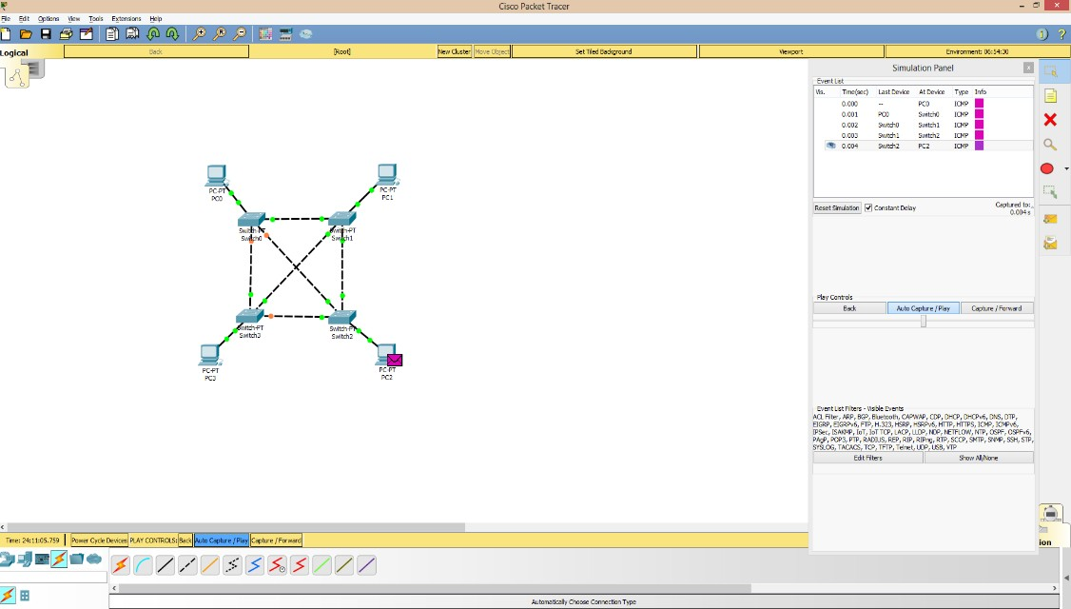

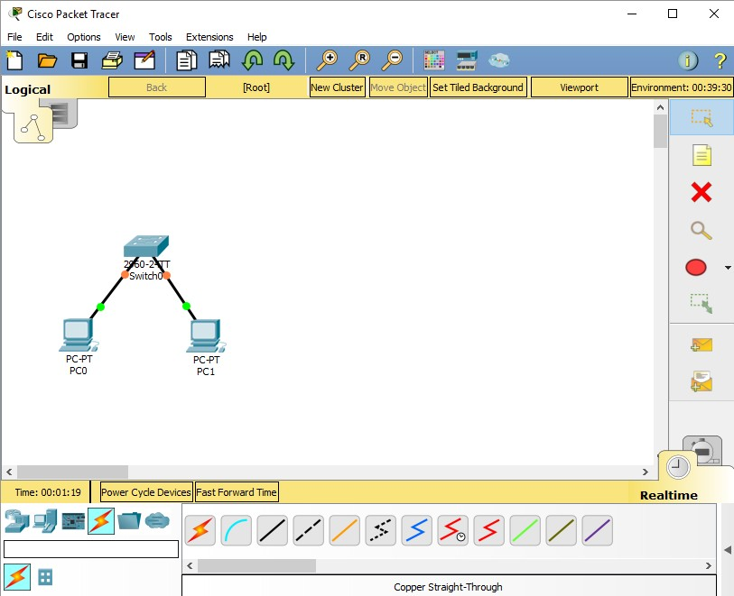

**Star Topology:**

1. Pick Generic PC-PT and drag on the workspace. An icon with PC0 tag will appear.
2. Pick Generic PC-PT and drag on the workspace. An icon with PC1 tag will appear.
3. Pick Generic Switch-PT and drag on the workspace. An icon with Switch0 tag will appear.
4. Use Copper Straight-Through Wire Cabling to connect both PC with fast Ethernet 0 to Switch0.
5. Double click PC0 and click on desktop configuration. Choose IP configuration and change IP to 172.16.1.1 and subnet mask to 255.255.0.0.
6. Double click PC1 and click on desktop configuration. Choose IP configuration and change IP to 172.16.1.2 and subnet mask to 255.255.0.0.

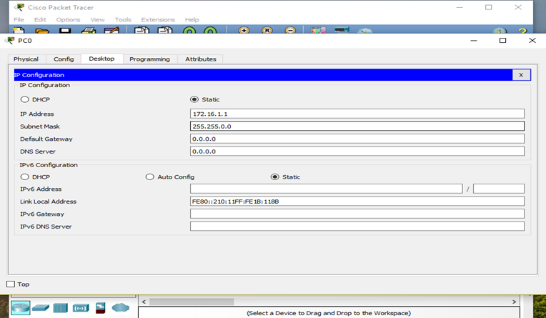

1. Add simple PDU (Protocol Data Unit), i.e., Packet and drop it at PC0 and PC1.
2. Click on Simulation button in right toolbar and click on Auto Capture / Play button.

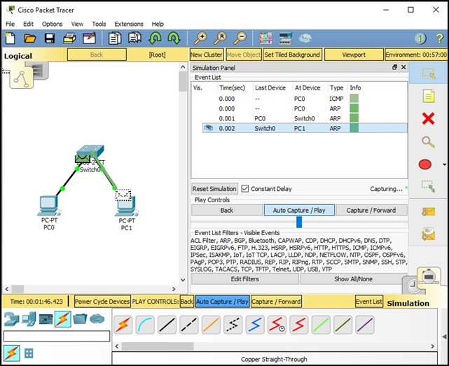

1. When Capture / Forward button is clicked, another PDU will be forwarded to other PC while the transmission of receiving PDU will pause.

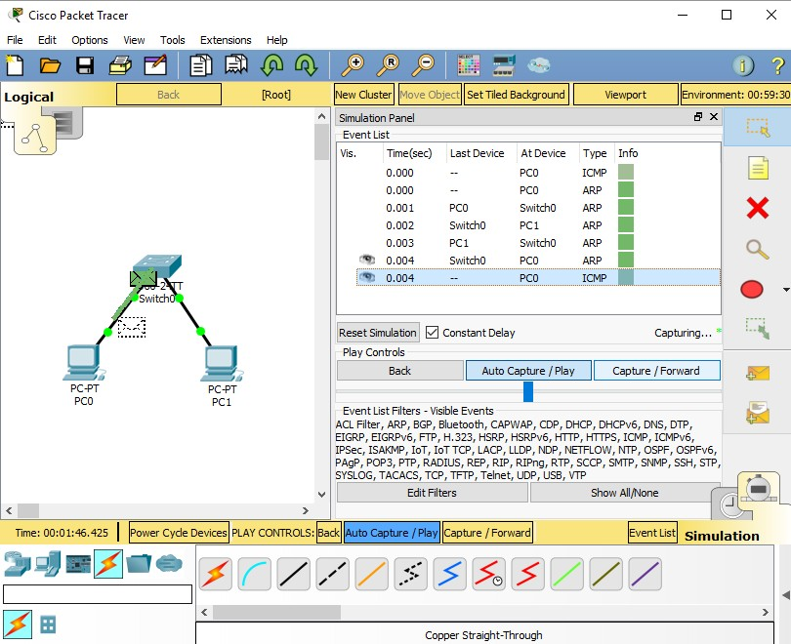

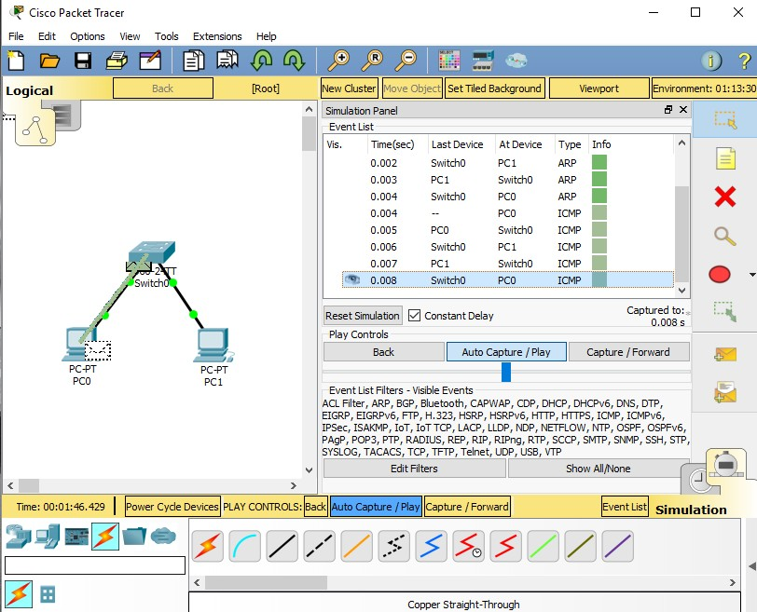

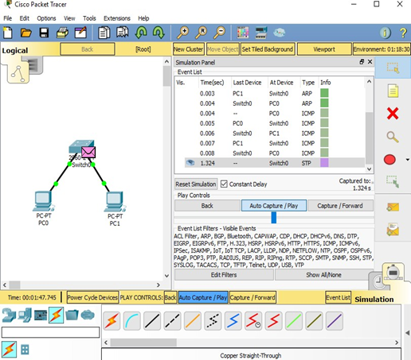

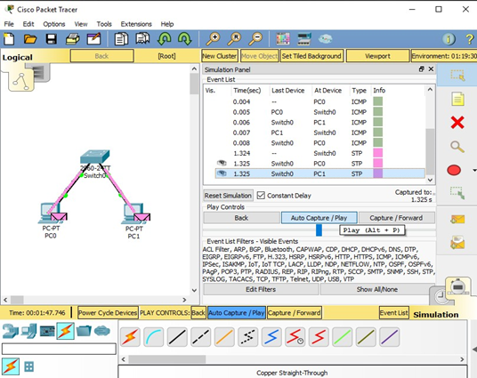

**Ring Topology:**

1. Pick Generic PC-PT and drag on the workspace. An icon with PC0 tag will appear.
2. Pick Generic PC-PT and drag on the workspace. An icon with PC1 tag will appear.
3. Pick Generic PC-PT and drag on the workspace. An icon with PC2 tag will appear.
4. Pick Generic PC-PT and drag on the workspace. An icon with PC3 tag will appear.
5. Pick 2950-24 Switch and drag on the workspace. An icon with Switch0 tag will appear.
6. Pick 2950-24 Switch and drag on the workspace. An icon with Switch1 tag will appear.
7. Pick 2950-24 Switch and drag on the workspace. An icon with Switch2 tag will appear.
8. Pick 2950-24 Switch and drag on the workspace. An icon with Switch3 tag will appear.
9. Use Copper Cross-Wire Cabling to connect all the Switches together with fast Ethernet 0/1, 0/2, 0/3 and 0/4 respectively.
10. Use Copper Straight-Through Wire Cabling to connect all the Switches with the PCs with fast Ethernet 0 to Switch0, Ethernet 1 to Switch1, Ethernet 2 to Switch2 and Ethernet 3 to Switch3 respectively.

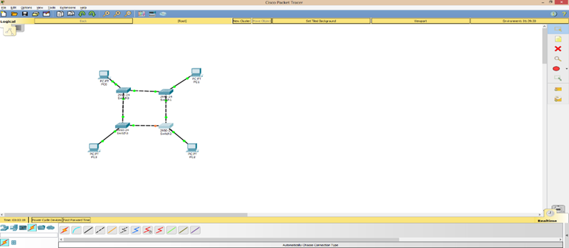

1. Double click PC0 and click on desktop configuration. Choose IP configuration and change IP to
2. 172.16.1.1 and subnet mask to 255.255.0.0.
3. Double click PC1 and click on desktop configuration. Choose IP configuration and change IP to 172.16.1.2 and subnet mask to 255.255.0.0.
4. Double click PC2 and click on desktop configuration. Choose IP configuration and change IP to
5. 172.16.1.3 and subnet mask to 255.255.0.0.
6. Double click PC3 and click on desktop configuration. Choose IP configuration and change IP to
7. 172.16.1.4 and subnet mask to 255.255.0.0.

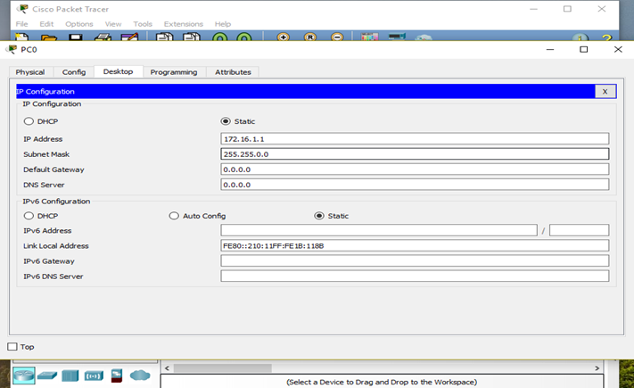

1. Add simple PDU (Protocol Data Unit), i.e., Packet and drop it at PC0 and PC2.
2. Click on Simulation button in right toolbar and click on Auto Capture / Play button.

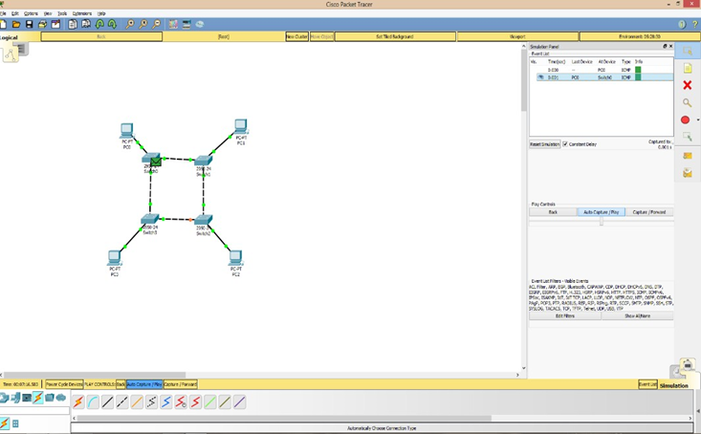

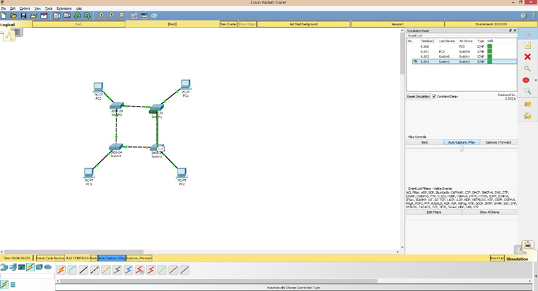

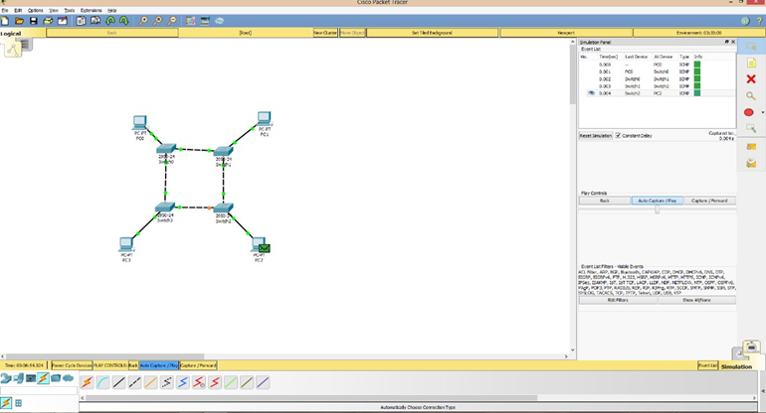

**Bus Topology:**

1. Pick Generic PC-PT and drag on the workspace. An icon with PC0 tag will appear.
2. Pick Generic PC-PT and drag on the workspace. An icon with PC1 tag will appear.
3. Pick Generic PC-PT and drag on the workspace. An icon with PC2 tag will appear.
4. Pick Generic PC-PT and drag on the workspace. An icon with PC3 tag will appear.
5. Pick Generic Switch and drag on the workspace. An icon with Switch0 tag will appear.
6. Pick Generic Switch and drag on the workspace. An icon with Switch1 tag will appear.
7. Pick Generic Switch and drag on the workspace. An icon with Switch2 tag will appear.
8. Pick Generic Switch and drag on the workspace. An icon with Switch3 tag will appear.
9. Use Copper Cross-Wire Cabling to connect all the Switches together with fast Ethernet 0/1, 0/2, 0/3 and 0/4 respectively.
10. Use Copper Straight-Through Wire Cabling to connect all the Switches with the PCs with fast Ethernet 0 to Switch0, Ethernet 1 to Switch1, Ethernet 2 to Switch2 and Ethernet 3 to Switch3 respectively.

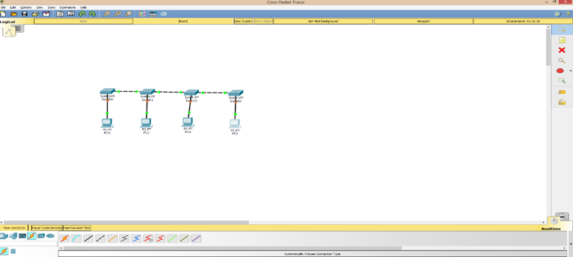

1. Double click PC0 and click on desktop configuration. Choose IP configuration and change IP to 172.16.1.1 and subnet mask to 255.255.0.0.
2. Double click PC1 and click on desktop configuration. Choose IP configuration and change IP to 172.16.1.2 and subnet mask to 255.255.0.0.
3. Double click PC2 and click on desktop configuration. Choose IP configuration and change IP to 172.16.1.3 and subnet mask to 255.255.0.0.
4. Double click PC3 and click on desktop configuration. Choose IP configuration and change IP to 172.16.1.4 and subnet mask to 255.255.0.0.

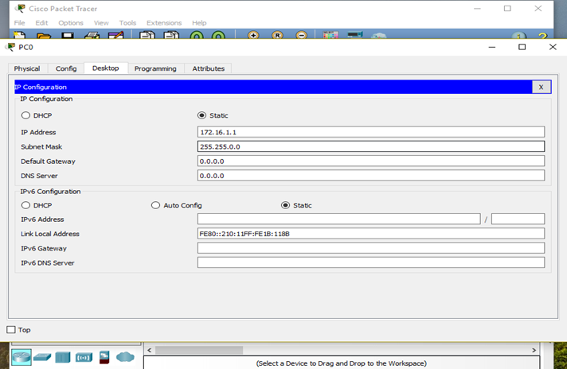

1. Add simple PDU (Protocol Data Unit), i.e., Packet and drop it at PC0 and PC3.
2. Click on Simulation button in right toolbar and click on Auto Capture / Play button.

